Directions to The Black Tavern
138 Center Road Dudley, MA 01571
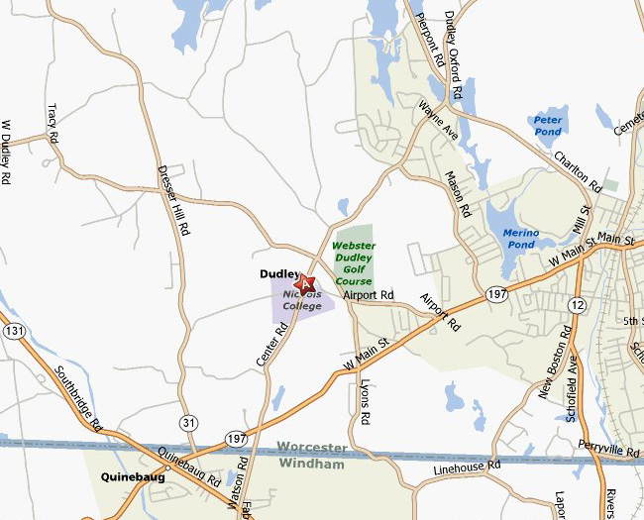
From Points North:
Take I-290 to Auburn, where I-290 becomes I-395 South.* Follow to Exit 4B (Sutton Road/Oxford center). Turn right off ramp and stay in the right lane. Go straight through the light at Oxford center (Cumberland Farms on right). Follow straight past light for 0.8 miles and take a left onto Dudley Road (produce stand is on the right). Follow this road for 3.7 miles, staying straight through a four-way stop sign. Dudley Road becomes Dudley/Oxford Road at the town line. Bearing right at the fork (pond on your right), continue on Dudley/Oxford Road for 2 miles through two stop signs, then straight toward the Nichols College campus. The Tavern will be on your left.
From Points East & West:
Take the Mass Pike to Exit 10 in Auburn and get on 395 South. Follow directions from (Points North) above *.
From Hartford, CT –NY City:
Take I-84 East towards Boston. Take Exit 2 (Sturbridge/Southbridge). When on exit ramp, keep right at the fork. Turn left onto Haynes Street. Turn right onto MA-131/Main Street. Proceed to rotary in Southbridge and take the first right onto MA-169/MA-131. You will pass through Dudley, Massachusetts, then enter Thompson Connecticut for a short while. Turn left onto Rt-197 in Thompson. You will re-enter Dudley Massachusetts on Route 197. Turn left onto Center Road. And follow up the hill through the Nichols College campus. The Tavern will be on your right.
From Other Points South:
Take I-95 North to I-395 North to Exit 2, (Webster) and turn left off the ramp. Go straight through the first set of traffic lights. Follow Route 12 South (Route 12 will turn left through Webster center). Continue through Webster center. After the railroad tracks, continue straight into Dudley. You will come to a set of lights. Route 12 will bear off to the left, but stay straight on Route 197 – do not turn left. Route 197 is also Main Street in Dudley. Stay straight on Main Street ( Rt. 197) until you reach a set of lights next to Cumberland Farms. Turn right directly after Cumberland Farms onto Airport Rd. Follow Airport Road and bear right at the Webster-Dudley Golf Course. Take the first left onto Center Rd and proceed directly onto the Nichols College campus. The Black Tavern will be on your Left.
